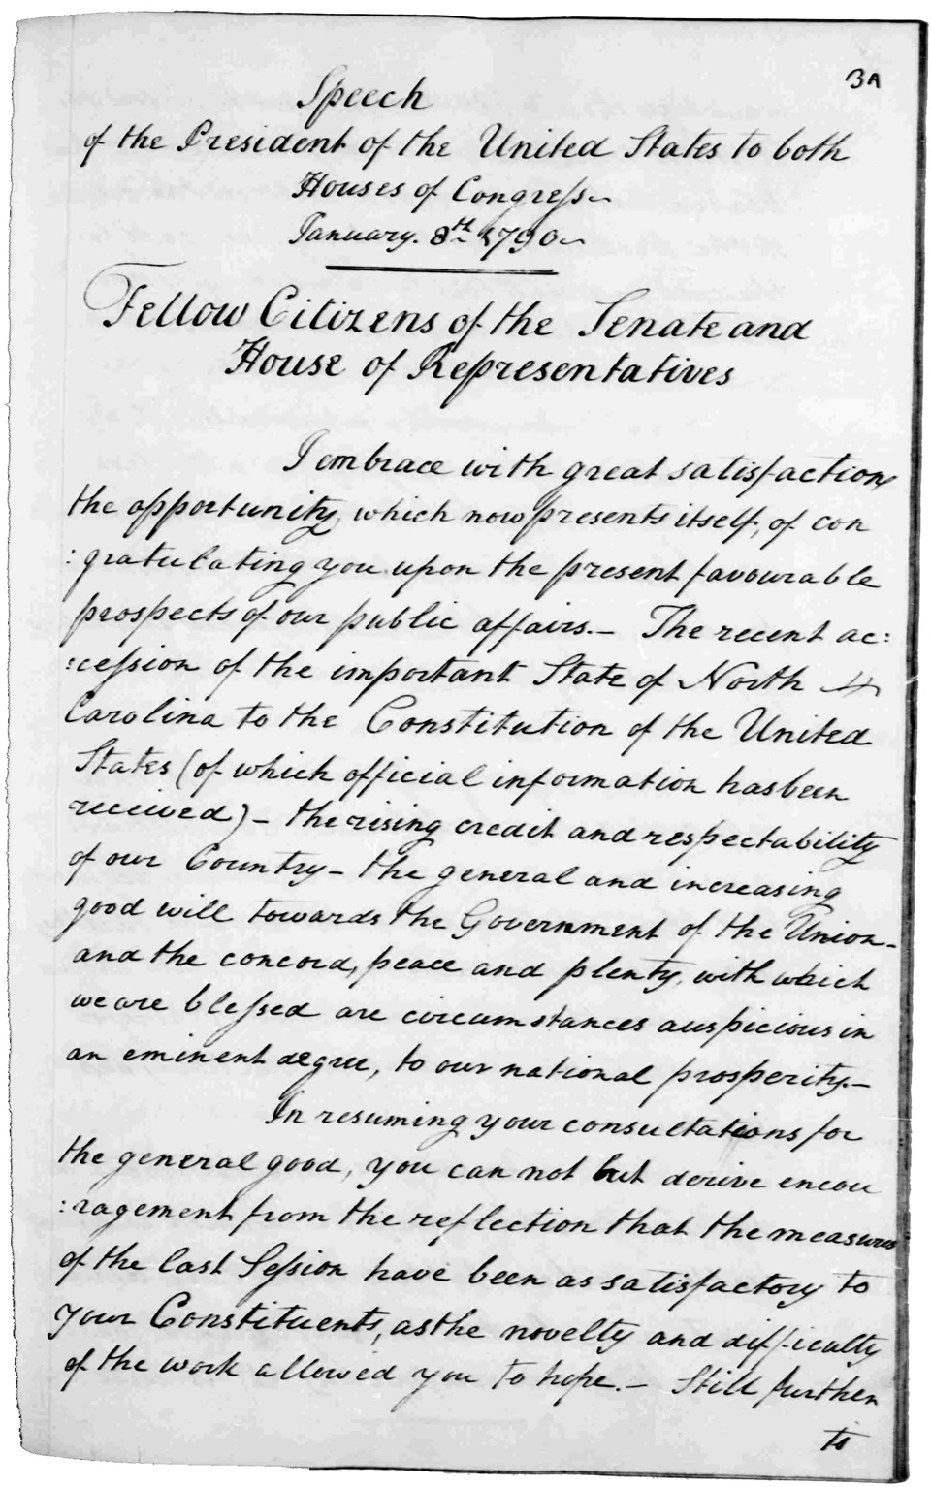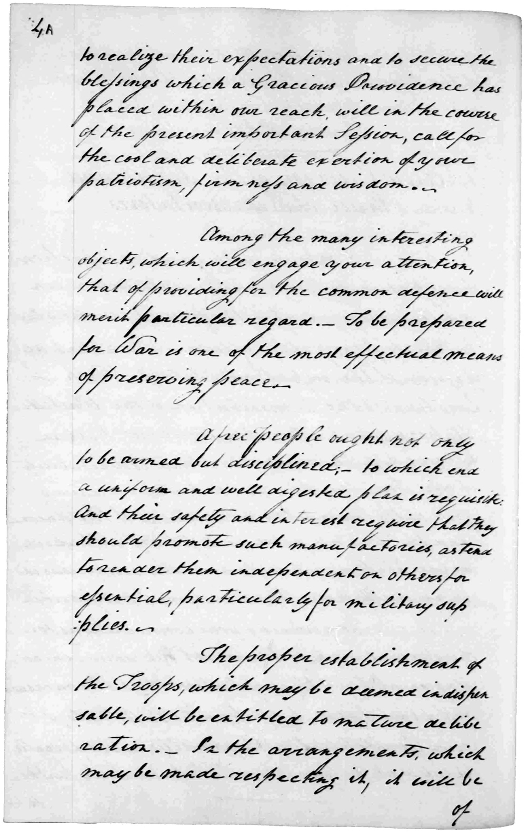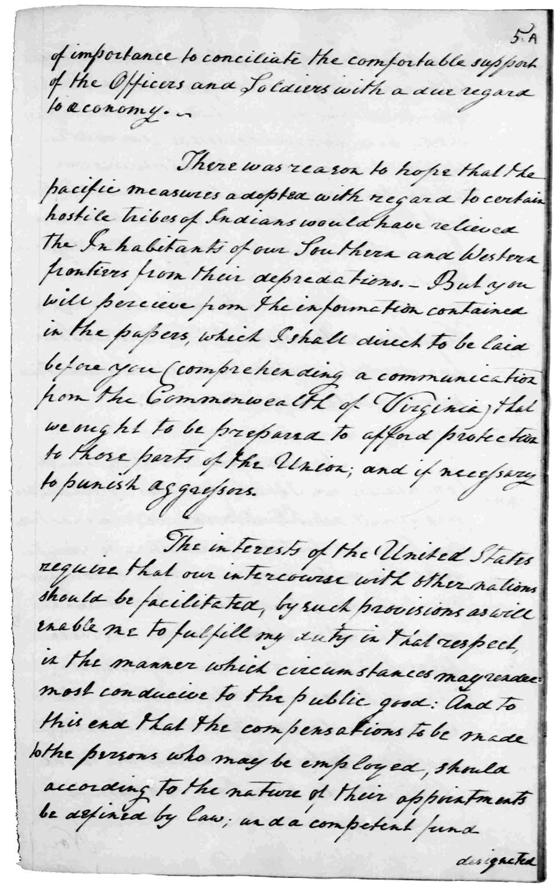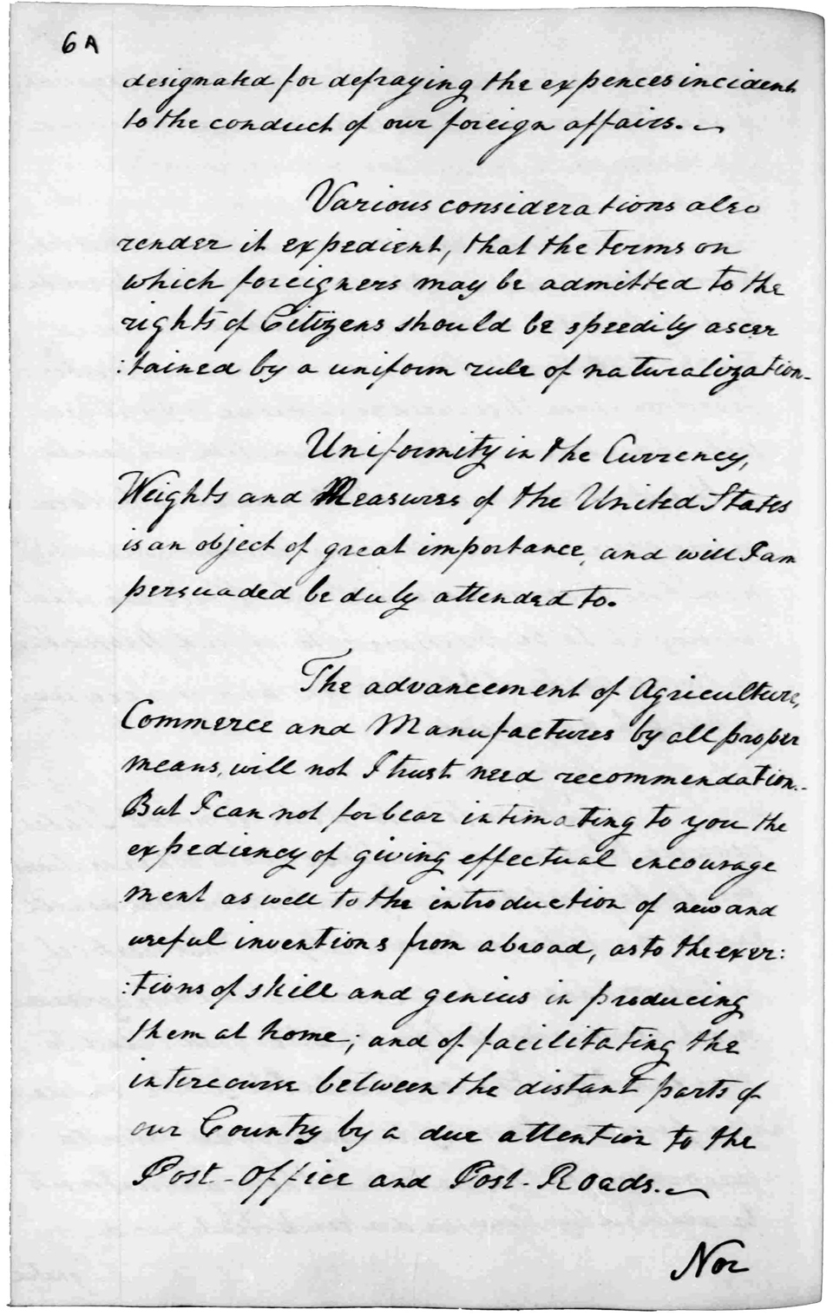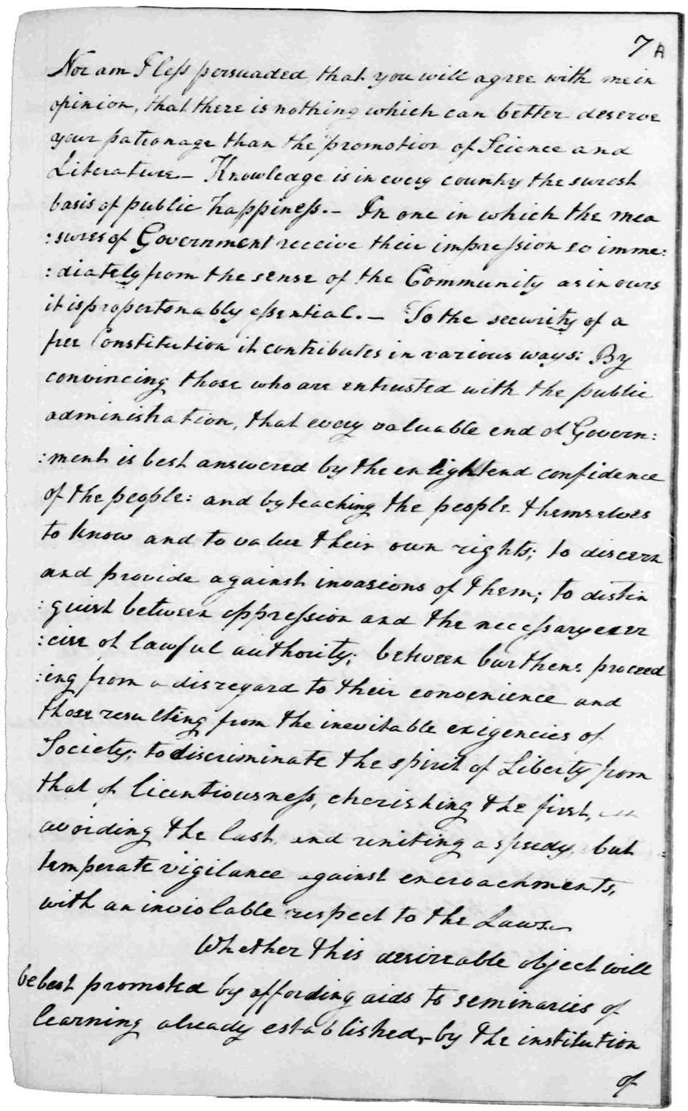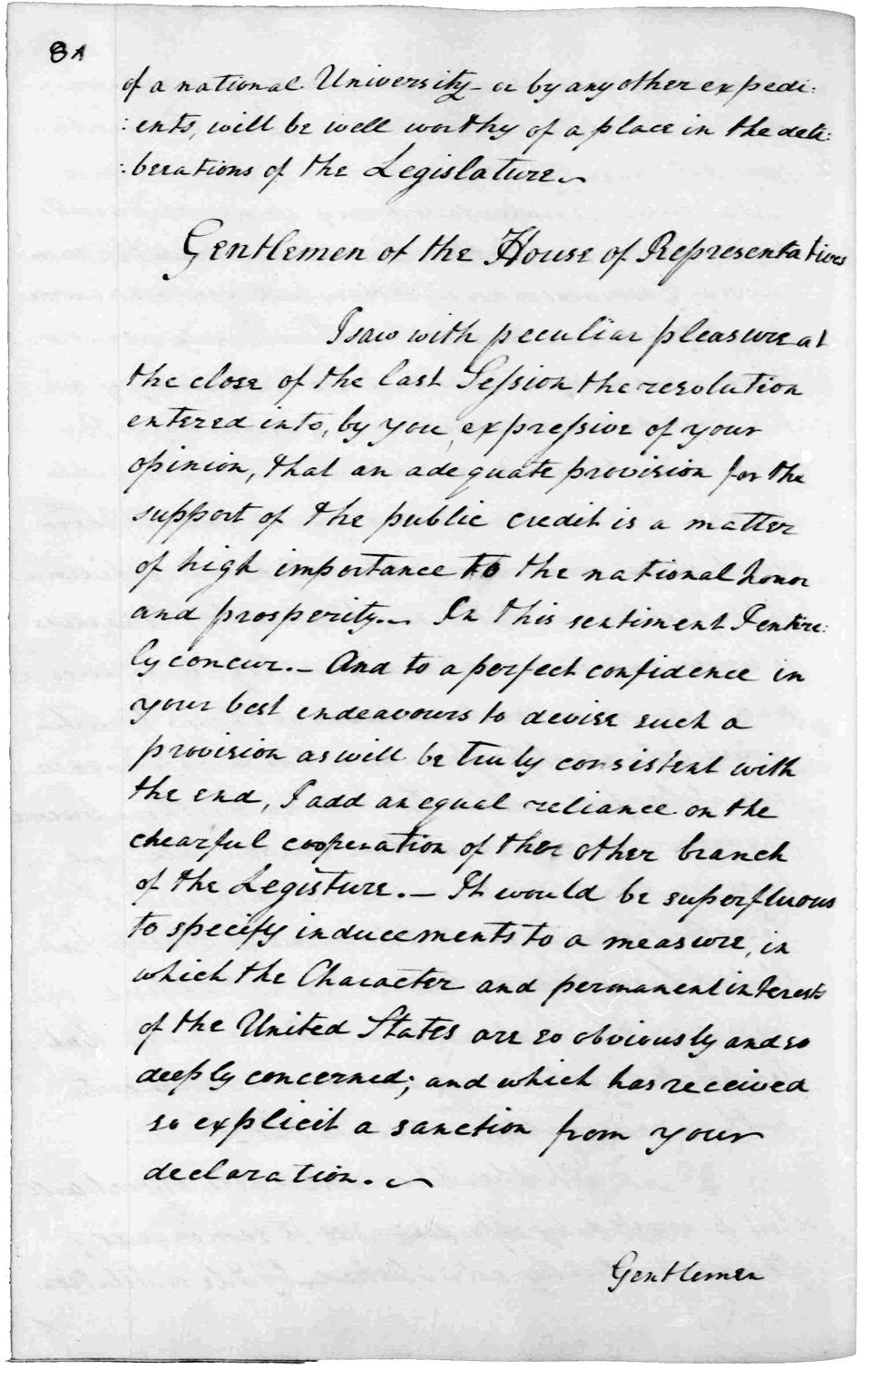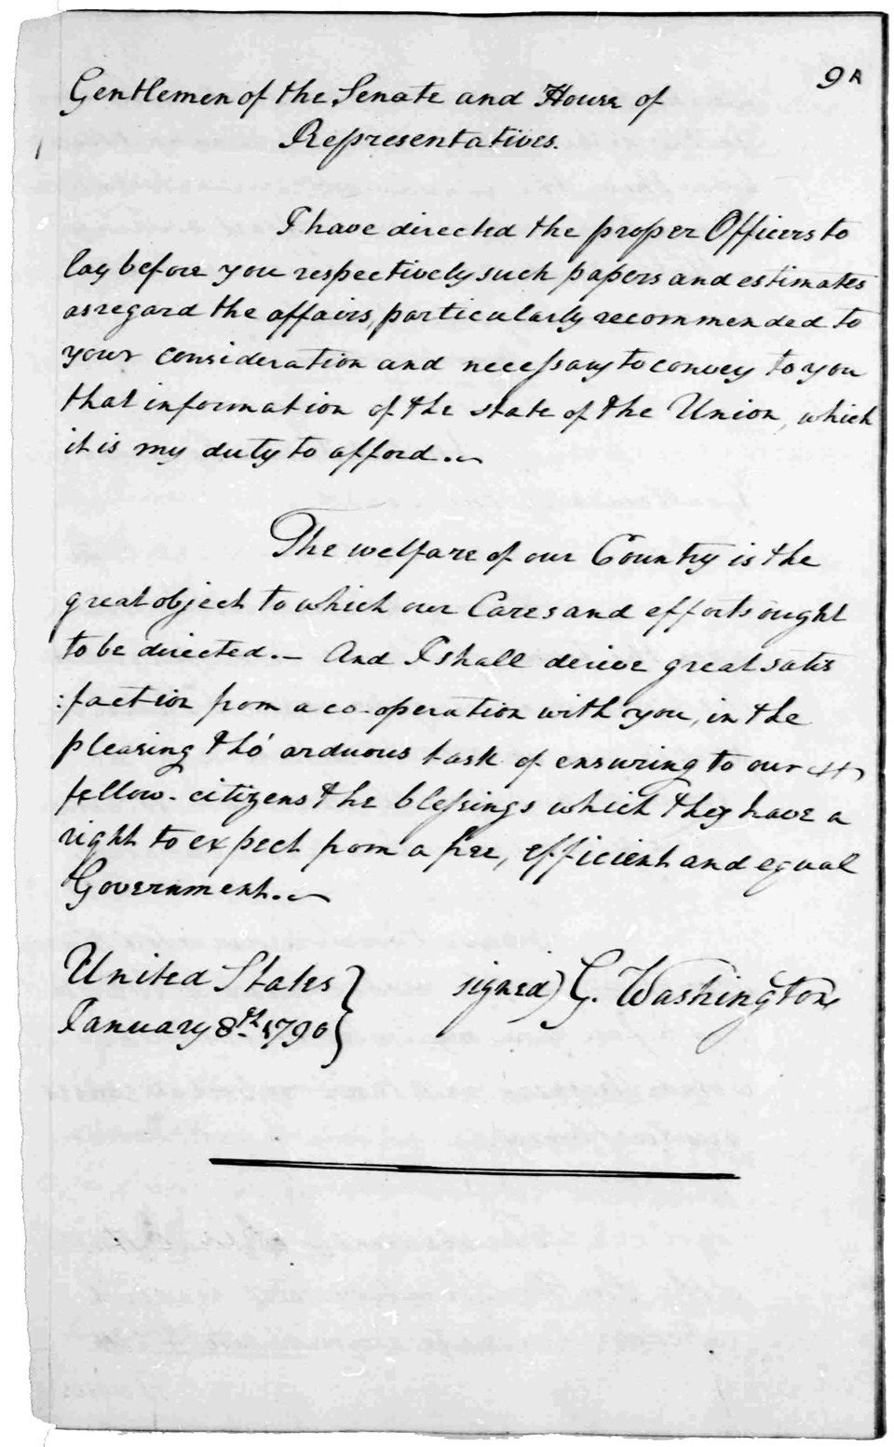

1. What is the most important thing that Washington is talking about- in your opinion? EXPLAIN why. *3 full sentences*

Use a QR reader app to scan this 🡪

|  |  |
| --- | --- |
| George Washington’s  State of the Union  Address | SUMMARIZE WHAT WASHINGTON IS SAYING ON THIS PAGE WITH 2 FULL SENTENCES |
| 3A |  |
| 4A |  |
| 5A |  |
| 6A |  |
| 7A |  |
| 8A |  |
| 9A |  |

Name:

Class:

1. What is the most important thing that Washington is talking about- in your opinion? EXPLAIN why. *3 full sentences*

Use a QR reader app to scan this 🡪

|  |  |
| --- | --- |
| George Washington’s  State of the Union  Address | SUMMARIZE WHAT WASHINGTON IS SAYING ON THIS PAGE WITH 2 FULL SENTENCES |
| 3A |  |
| 4A |  |
| 5A |  |
| 6A |  |
| 7A |  |
| 8A |  |
| 9A |  |

Name:

Class:

1. What is the most important thing that Washington is talking about- in your opinion? EXPLAIN why. *3 full sentences*

Use a QR reader app to scan this 🡪

|  |  |
| --- | --- |
| George Washington’s  State of the Union  Address | SUMMARIZE WHAT WASHINGTON IS SAYING ON THIS PAGE WITH 2 FULL SENTENCES |
| 3A |  |
| 4A |  |
| 5A |  |
| 6A |  |
| 7A |  |
| 8A |  |
| 9A |  |

Name:

Class:

1. What is the most important thing that Washington is talking about- in your opinion? EXPLAIN why. *3 full sentences*

Use a QR reader app to scan this 🡪

|  |  |
| --- | --- |
| George Washington’s  State of the Union  Address | SUMMARIZE WHAT WASHINGTON IS SAYING ON THIS PAGE WITH 2 FULL SENTENCES |
| 3A |  |
| 4A |  |
| 5A |  |
| 6A |  |
| 7A |  |
| 8A |  |
| 9A |  |

Name:

Class:

1. What is the most important thing that Washington is talking about- in your opinion? EXPLAIN why. *3 full sentences*

Use a QR reader app to scan this 🡪

|  |  |
| --- | --- |
| George Washington’s  State of the Union  Address | SUMMARIZE WHAT WASHINGTON IS SAYING ON THIS PAGE WITH 2 FULL SENTENCES |
| 3A |  |
| 4A |  |
| 5A |  |
| 6A |  |
| 7A |  |
| 8A |  |
| 9A |  |

Name:

Class:

1. What is the most important thing that Washington is talking about- in your opinion? EXPLAIN why. *3 full sentences*

Use a QR reader app to scan this 🡪

|  |  |
| --- | --- |
| George Washington’s  State of the Union  Address | SUMMARIZE WHAT WASHINGTON IS SAYING ON THIS PAGE WITH 2 FULL SENTENCES |
| 3A |  |
| 4A |  |
| 5A |  |
| 6A |  |
| 7A |  |
| 8A |  |
| 9A |  |

Name:

Class:

1. What is the most important thing that Washington is talking about- in your opinion? EXPLAIN why. *3 full sentences*

Use a QR reader app to scan this 🡪

|  |  |
| --- | --- |
| George Washington’s  State of the Union  Address | SUMMARIZE WHAT WASHINGTON IS SAYING ON THIS PAGE WITH 2 FULL SENTENCES |
| 3A |  |
| 4A |  |
| 5A |  |
| 6A |  |
| 7A |  |
| 8A |  |
| 9A |  |

Name:

Class: