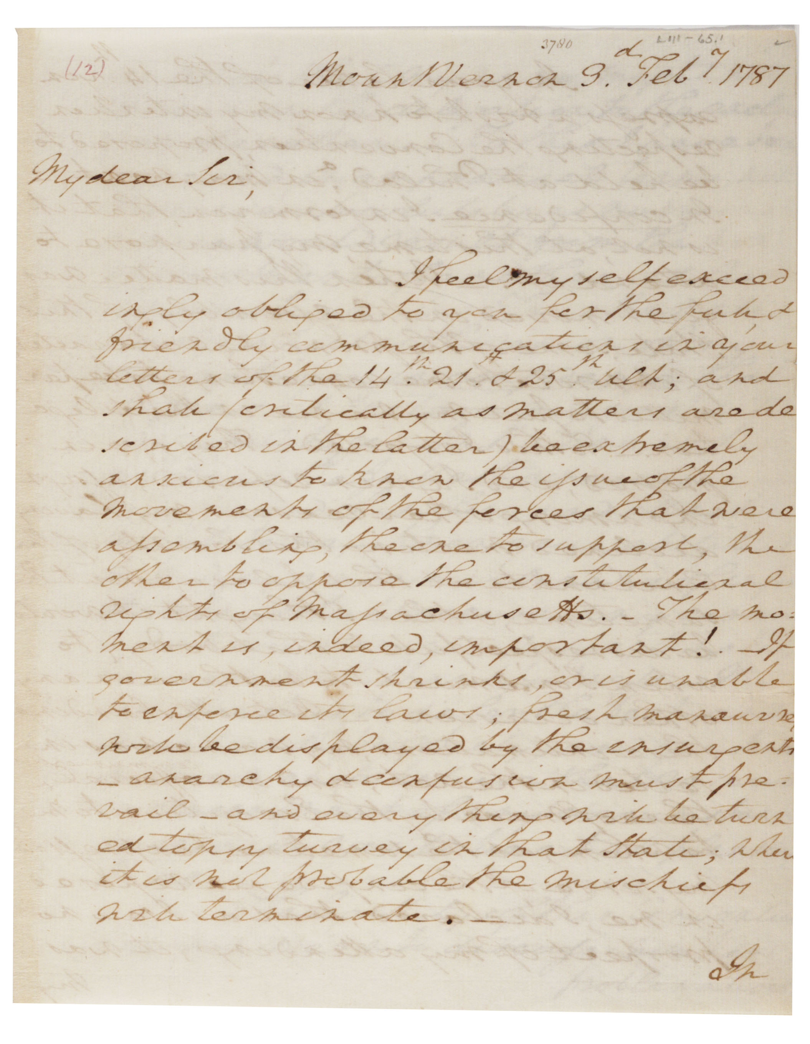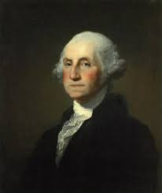

The following passage is from a letter written by George Washington to fellow

Virginian, Henry Lee, in which he shows great concern for the future if Shays’ uprising in Massachusetts

cannot be resolved quickly.

“The picture which you have exhibited [in your letter] … of the commotions and

temper of numerous bodies in the eastern States, are equally to be lamented and

deprecated. They [the incidents] exhibit a melancholy proof of what our transatlantic foe

[England] has predicted; and of another thing perhaps, which is still more to be

regretted, and is yet more unaccountable, that mankind, when left to themselves, are

unfit for their own government. I am mortified beyond expression when I view the

clouds that have spread over the brightest morn that ever dawned upon any country. In

a word, I am lost in amazement when I behold what intrigue, the interested views of

desperate characters, ignorance, and jealousy of the minor part [the rebels], are capable

of effecting, as a scourge on the major part of our fellow citizens of the union; for it is

hardly to be supposed, that the great body of the people [the majority], though they will

not act, can be so sort-sighted or enveloped in darkness, as not to see rays of distant

sun through all this mist of intoxication and folly.

“You talk, my good Sir, of employing [using] influence to appease the present tumults

in Massachusetts. I know not where that influence is to be found, or, if attainable, that

it would be a proper remedy for the disorders. Influence is no government. Let us have

one [a government] in which our loves, liberties, and properties will be secured, or let us

know the worst at once. Under these impressions, my humble opinion is, that there is a

call for decision. Know precisely what the insurgents [rebel farmers] aim at. If they have

real grievances, redress [take care of] them if possible; or acknowledge the justice of

them, and your inability to do it in the present moment. If they have not [real

grievances], employ [use] the force of government against them at once. If this is

inadequate, all will be convinced that the superstructure is bad, or wants support. To

be more exposed in the eyes of the world, and more contemptible than we already are,

is hardly possible. To delay one or the other of these is to exasperate … or to give

confidence, and will add to their [the rebels] numbers; for, like snow-balls, such bodies

increase by every moment unless there is something in the way to obstruct and crumble

them before the weight is too great and irresistible….”

Name:

Class:

|  |  |  |  |  |  |  |  |
| --- | --- | --- | --- | --- | --- | --- | --- |
| 1. |  | TYPE OF DOCUMENT (Check one):   |  |  |  |  |  | | --- | --- | --- | --- | --- | | ___ Newspaper  ___ Letter  ___ Patent  ___ Memorandum |  | ___ Map ___ Telegram  ___ Press release  ___ Report |  | ___ Advertisement  ___ Congressional record  ___ Census report  ___ Other | |
| 2. |  | UNIQUE PHYSICAL QUALITIES OF THE DOCUMENT (Check one or more):   |  |  |  | | --- | --- | --- | | ___ Interesting letterhead ___ Handwritten ___ Typed ___ Seals |  | ___ Notations ___ "RECEIVED" stamp ___ Other | |
| 3. |  | DATE(S) OF DOCUMENT:  ___________________________________________________________________________ |
| 4. |  | AUTHOR (OR CREATOR) OF THE DOCUMENT:  ___________________________________________________________________________  POSITION (TITLE):  ___________________________________________________________________________ |
| 5. |  | FOR WHAT AUDIENCE WAS THE DOCUMENT WRITTEN? ___________________________________________________________________________ |
| 6. |  | DOCUMENT INFORMATION (There are many possible ways to answer A-E.)  A. List three things the author said that you think are important:   B. Why do you think this document was written?  C. What evidence in the document helps you know why it was written? Quote from the document.  D. List two things the document tells you about life in the United States at the time it was written:  E. Write a question to the author that is left unanswered by the document:  F. Does Washington have a wider audience in mind? Explain.  G. According to Washington, what is at risk if the rebels are not dealt with?  H. In your opinion, what does he mean by “Influence is no government.”  I. Explain the two pieces of advice that Washington gives to the Massachusetts government in  dealing with the insurgent farmers.  J. Why is he concerned with the “eyes of the world?” Should he be? Give reasons. |