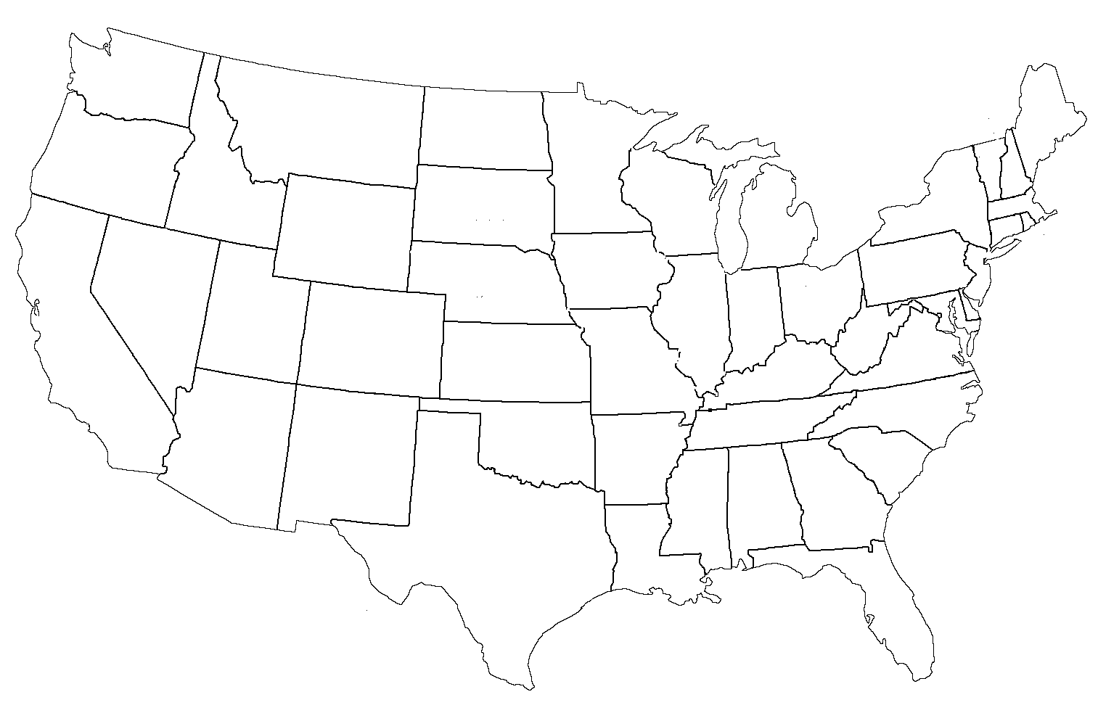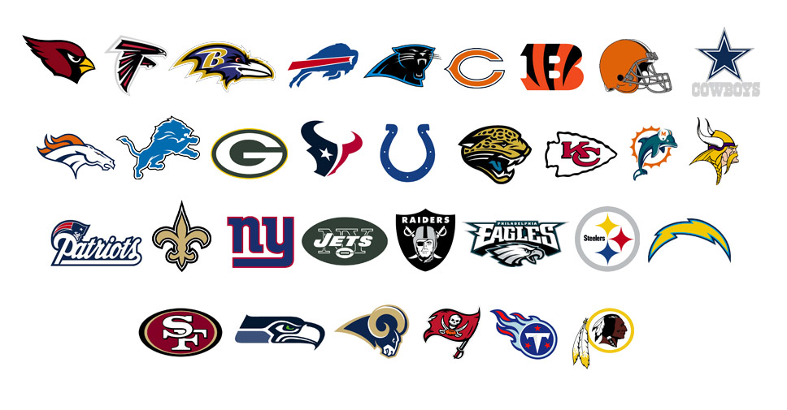

Use your Books and Technology!

Name:

Class:

The NFL and Geography

11. If you lived in Tampa, and the Buccaneers kickoff is at 2:00pm:

1. List the other NFL cities that could watch it at the same time
2. List NFL cities that watch it and when in the Central Time Zone
3. List NFL cities that watch it and when in the Mountain Time Zone
4. List NFL cities that watch it and when in the Pacific Time Zone

1. Number each of the logos to the left and then mark

those cities on the map on the flipside

2. Label all states with Capitols in the map

3. Using color pencils, trace out the 4 time zones

and label them.

4. List the states that have 2 or more NFL Franchises

5. List the states that have NO NFL franchises (2 not on map)

6. If you flew out of Phoenix which 3 NFL teams would take the longest to get there? How far are they?

7. If you flew out of Phoenix which 3 NFL team would take the Shortest to get there? How far are they?

8. What is the largest city that has a NFL team? Population?

9. What is the largest city that does NOT have an NFL team? Population?

10. What’s the smallest city to have a Team? Population?