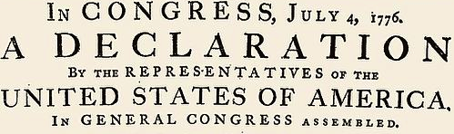

Continental Army

British Army

Disadvantages

Advantages

Advantages

Disadvantages

Where, When, Why?

Part One: Preamble

Part Two: Grievances

Part Five: Declaration

Part Three: Politics

Part Four: Reconciliation