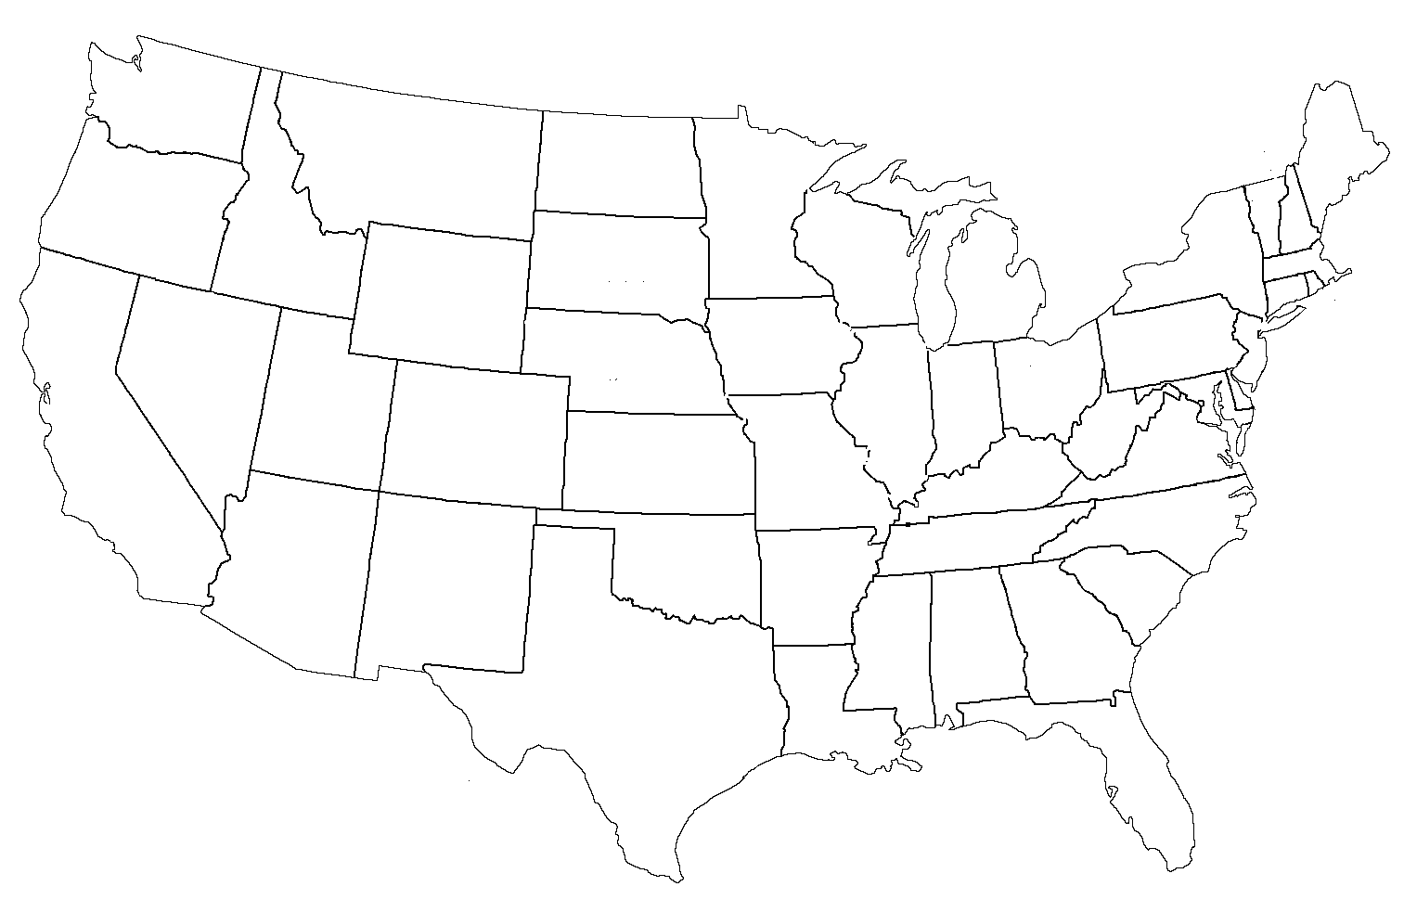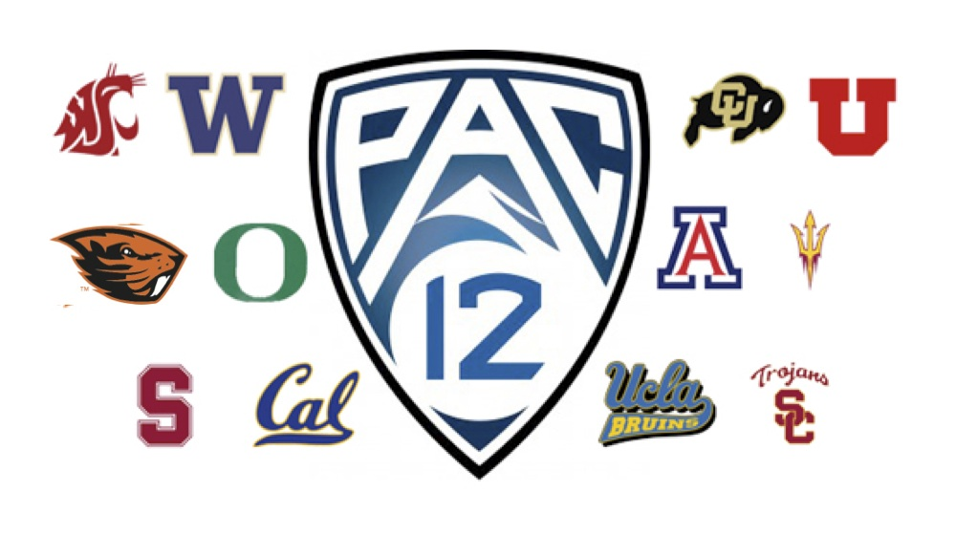

NCAA and Geography

Name:

Class:

1. Number each of the logos to the left and then mark those cities on the map on the flipside

2. Label all states in the map

3. Using color pencils, trace out the 3 time zones and label them.

4. List the states that have 3 or more PAC 12 universities

5. List the states that have 1 PAC 12 University.

6. If you flew out of Phoenix which college teams would take the longest to get there? How far are they?

7. If you flew out of Phoenix which 3 college teams would take the Shortest to get there? How far are they?

8. What is the largest city that has a PAC 12 team?

9. What is the largest city that does NOT have a PAC 12 team?

10. What is the smallest city to have an MLB franchise?

11. Identify the rivals for each PAC 12 team and their distance apart. Which is the closest? Which is the farthest?