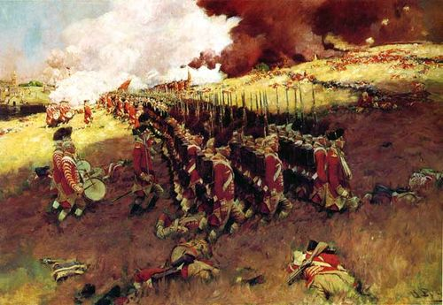
BUNKER HILL READING 1
Tension between the British government and the American colonists had been steadily mounting during the months after the battles of Lexington and Concord. The British sent three important major generals--John Burgoyne, William Howe, and Henry Clinton--to help Royal Governor Thomas Gage deal with the increasingly rebellious colonists in Massachusetts. Patriots established encampments along the Mystic and Charles Rivers and in nearby Roxbury. Early in the evening of June 16, 1775, about 800 Massachusetts and 200 Connecticut troops assembled and marched past patriot commander Col. William Prescott of Massachusetts.
The only man wearing a uniform at this parade of troops was Colonel Prescott. He was also the only one who knew that the farmers and artisans turned soldiers would soon be preparing for battle against the British. Colonial spies had alerted the Patriot for an imminent attack. Gen. Artemas Ward, the commander of the American forces gathered around Boston, ordered Prescott and his men to provoke an attack, hoping that surprise would allow the patriots to outmaneuver the British. Ward and Prescott decided that the best place for this gambit was Bunker Hill, on the Charlestown Peninsula, north of Boston. The soldiers themselves knew nothing of this plan. They were told to be prepared and to be armed. Most carried muskets with the ammunition in pouches slung crossways over their vests. They wore jackets or long coats and low­heeled shoes with buckles. Only the very rich could afford to wear more practical boots.
After the troops had passed in review, they took part in a prayer and then were told that under cover of darkness they would march to prepare for battle. So they would not give their position away to the British, they were to march as quietly as possible and to stay absolutely silent. At about 9 p.m. they set out, led by two sergeants who carried lanterns, and followed by carts filled with shovels, pick axes, and other tools appropriate for excavating and moving earth.
Near Charlestown Neck they were called to a halt while several other officers joined the column of men. As they began the march again, the Mystic River was to their left and the Charles River to their right. They crossed the neck, and then climbed up and over a hill. By now they were surrounded by water on three sides. Off to their right were the buildings of Charlestown. Across the water ahead they could see Boston. They had reached Bunker Hill. Again the men were called to a halt. Prescott and Gen. Israel Putnam of Connecticut called the engineer, Col. Richard Gridley, and other officers to gather round them to discuss the written orders they had received from General Ward. The orders had stated for them to fortify Bunker Hill, which stood 110 feet high, the largest of the hills around Charlestown. After a prolonged discussion, however, the officers eventually decided to move closer to Boston and fortify the smaller, lesser known, 62-foot-high hill known as Breed’s Hill.
By now it was nearly midnight, and the troops had to hurry their work if they were to have it completed by dawn. They were to build a redoubt and a breastwork in only a few short hours. The redoubt was to be a rectangular fort about 160 feet long and 80 feet wide, with six- to eight-foot-high earthen walls. Within the walls would be platforms for the soldiers to use as they shot out at the enemy. The breastwork, a long arm of logs and dirt, was to run from the redoubt to a swamp at the bottom of the hill, adding protection for the patriot militiamen. They dug the redoubt’s foundation, using the excavated dirt for the redoubt’s walls. To support those walls they used tree branches, whole and broken barrels—anything they could find that would provide strength. Then they packed the walls with mud to stabilize the structure and dug a trench around the redoubt. All this work was made especially difficult by the need for silence. The men were on top of a hill and they were surrounded by water, an excellent carrier of sound. Some troops were sent to patrol the shore watching for indications that sailors aboard the British warships had heard them and raised an alarm. Some of the men were sent to Charlestown to keep watch on the shoreline of Boston. All through the night Colonel Prescott watched and encouraged the men. He worried about what was to come. He knew the capabilities of his own men who had been well-trained, but he knew that most of the soldiers had never before heard gunfire except on a hunt. He did not know how they would react to combat.
By dawn, the redoubt was nearly completed, but there was still much work needed on the breastwork. Some of the men tried to get a little rest and have a bite to eat before they continued their efforts. They had little food with them, however, because they had been told to travel light. As dawn broke, sailors on the British sloop-of-war Lively noticed the fortifications and opened fire. The Battle of Bunker Hill that took place on Breed’s Hill was about to begin.

NAME:
PARTNER:

Questions for Reading 1
- Why would both the British and the colonists have wanted to control the Charlestown Peninsula?

- When did the patriot troops realize they were preparing for battle and not simply taking part in a training exercise?

- Why do you think the colonists disregarded their orders to fortify Bunker Hill and moved forward to Breed's Hill?

Questions for Reading 2

- Why do you think the colonial officers needed to boost morale during the fortification of Breed's Hill?

- Why do you think the appearance of Dr. Joseph Warren had a positive effect on the troops from Massachusetts? In turn, what impact did his death have on them?

- Why did the colonists hold their fire until the British were almost upon the redoubt?

- How many assaults did the British army make during the Battle of Bunker Hill?

- After the Battle of Bunker Hill, the British considered abandoning the use of the frontal assault. Why? Do you think this method of assault was effective?

- If the Battle of Bunker Hill was a military defeat for the colonists, why do you think it was considered decisive in uniting the colonists into a Continental army?

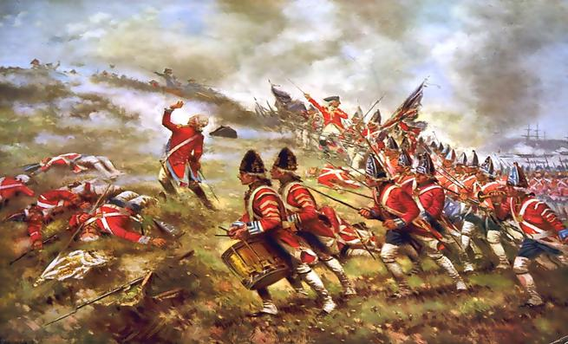
BUNKER HILL READING #2

In Boston, the British heard rumors about the patriots’ activities. Governor Gage was advised by Major General Clinton that they should be prepared to mount a dawn attack on the Charlestown Peninsula, but Gage believed the early reports of patriot troop movement were overstated. He chose to wait for daylight before he decided what to do. When daybreak came, Gage saw that the noise he thought represented the change of patriot sentries had been caused by the building of an imposing fortification.
Prescott’s militiamen had worked for about 12 hours, they had little, if anything, to eat, and they had no drinking water. Some expected to be relieved by other troops and were shocked when Prescott informed them that nearby troops had to stand ready in case the British attacked at another point. He did send for a few additional soldiers and for some food and water, but he made it clear that those who had built the redoubt would be its defenders.
Meanwhile the British had decided to land troops at Morton’s Point, march up the hill, and dislodge the patriot militiamen Governor Gage then assigned positions: Major General Howe with Brig. Gen. Robert Pigot under his command would lead the attack; Brig. Gen. Sir Hugh Percy would be in charge of troops at Boston Neck; Clinton would wait in Boston until Howe signaled him for help; and Major General Burgoyne would command guns at Copp’s Hill.
By 1 p.m. British regulars began landing on Morton’s Point. They quickly formed lines and marched to the foot of Breed’s Hill. Then in sight of the tired and hungry patriot troops, they unpacked substantial meals and sat down to eat. Hungry, thirsty, tired, and terrified, the Americans wondered what would come next. Their spirits revived a bit when Dr. Joseph Warren came as a volunteer to help in the fight. The men from Massachusetts considered his appearance to be a happy omen. An important leader of the patriot cause and a newly commissioned major general, Warren was as well known locally as Samuel Adams and John Hancock. Then, as the British soldiers completed their meal, General Putnam brought patriot militia to dig in on Bunker Hill.
From the warships and from Copp’s Hill came bombardments of ball and shot. Approximately 1,100 British troops under Howe set out along the beach of the Mystic River to outflank the colonists. The remaining 1,100 soldiers under Pigot started up the hill toward the patriots’ redoubt. Both groups wore heavy red-woolen coats, bore heavy packs on their backs, and carried fixed bayonets that glinted in the sun. The progress of Pigot’s troops over the uneven, grass-covered ground was slow, and the Americans were anxious to begin shooting them down. Mindful of their small amount of ammunition, colonial officers cautioned the troops to use their weapons carefully. Legend has it that Prescott uttered the famous line, "Don’t fire until you see the whites of their eyes" to encourage soldiers to make each shot as effective as possible. Colonial officers also told troops to aim low and try to hit the officers, the men in the fanciest uniforms, in order to break up the British chain of command.
The first assault by the British forces came from the Mystic River beach when Howe gave the order for his soldiers to overrun the rail fence and the breastworks below the redoubt. When the command to fire finally came, patriot soldiers shot with deadly accuracy. The British lines broke as one redcoat after another dropped under the feet of his comrades. Soon the call for retreat resounded. The American colonists had repelled a major assault by the superior British army.
Within minutes Pigot’s forces were in position to attack the front of the redoubt. The British soldiers found it difficult to march up the hill. They each carried 60 pounds of equipment and had to wade through tall grass and step over stonewalls as they climbed the steepest part of the hill on a hot June afternoon. Again the patriots withheld their fire until the British regulars were within 50 yards. They shot with deadly accuracy and again the British lines were broken as officers and soldiers dropped to the ground, killed or wounded. Again came the order for retreat.
The British generals watching the battle from Copp’s Hill could not believe that backwoods colonials were slaughtering what they had deemed to be the finest soldiers in the world. After receiving orders from Gage to supply additional reinforcements, Clinton arrived in Charlestown with men from the 2nd Marine Battalion and the 63rd Regiment to support Pigot. Howe ordered his remaining haggard troops to once again form themselves into a marching line. He permitted them to take off their heavy packs and even allowed some to take off their bloodstained red coats.
Finally the third British advance was mounted against the redoubt and breastworks. Many terrified militiamen had already left the scene of battle. Most of those who remained had only one round of ammunition left with no hope of getting more. The British stormed the fort brandishing their bayonets. When the redcoats came close, the colonists fired one to two volleys then most stood their ground to face the British. Fierce hand­to­hand fighting occurred within the redoubt. Casualties were high on both sides. Among those killed during the third assault was patriot leader Dr. Warren. Those colonists who were not killed or captured began a headlong flight toward the Charlestown Neck and across to Cambridge.
The British took possession of both Breed’s Hill and Bunker Hill. They had won the battle, but at a terrible cost: out of 2,200 troops, 268 British soldiers and officers had been killed; another 828 were wounded. The Americans also suffered heavy casualties with 115 killed and 305 wounded. The British army’s military victory at the battle of Bunker Hill was a moral victory for the colonists, however. Colonists throughout America realized that the conflict was no longer just a rebellion of Bostonians and other Massachusetts colonists against British occupation. They had proved to themselves that, united, they had the ability and the character to confront the superior force of the British army. The cost of British victory was so great that serious doubts were raised about English leadership; many now understood that war with the colonies would be hard, long, and expensive to both sides.

Name:
Class:

Questions for Reading 1
- Why would both the British and the colonists have wanted to control the Charlestown Peninsula?

- When did the patriot troops realize they were preparing for battle and not simply taking part in a training exercise?

- Why do you think the colonists disregarded their orders to fortify Bunker Hill and moved forward to Breed's Hill?

Questions for Reading 2

- Why do you think the colonial officers needed to boost morale during the fortification of Breed's Hill?

- Why do you think the appearance of Dr. Joseph Warren had a positive effect on the troops from Massachusetts? In turn, what impact did his death have on them?

- Why did the colonists hold their fire until the British were almost upon the redoubt?

- How many assaults did the British army make during the Battle of Bunker Hill?

- After the Battle of Bunker Hill, the British considered abandoning the use of the frontal assault. Why? Do you think this method of assault was effective?

- If the Battle of Bunker Hill was a military defeat for the colonists, why do you think it was considered decisive in uniting the colonists into a Continental army?

